TOPIC 1 - INTRODUCTION

Experiment 1: First Palindromic String
Aim
To find the first palindromic string in an array of strings.
Algorithm
- Read the list of strings.
- Traverse each string.
- Check if the string equals its reverse.
- Print the first palindrome found.
- If none exists, print an empty string.
Code
words=["abc","car","ada","racecar","cool"]

for w in words:
if w==w[::-1]:
print(w)
break
Output
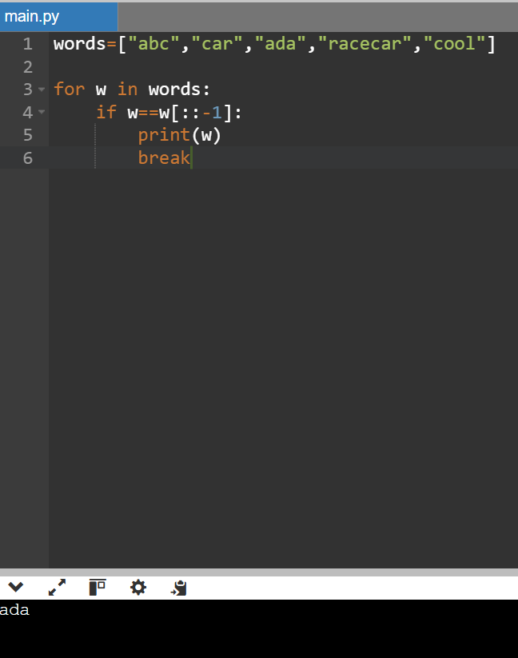

Result
Thus this program is executed successfully

Experiment 2: Count Common Elements
Aim
To find the count of elements of one array present in another array.
Algorithm
- Read two arrays.
- Count elements of nums1 present in nums2.
- Count elements of nums2 present in nums1.
- Display both counts.
Code
nums1=[2,3,2]
nums2=[1,2]

a1=sum(1 for x in nums1 if x in nums2)
a2=sum(1 for x in nums2 if x in nums1)

print([a1,a2])
Output
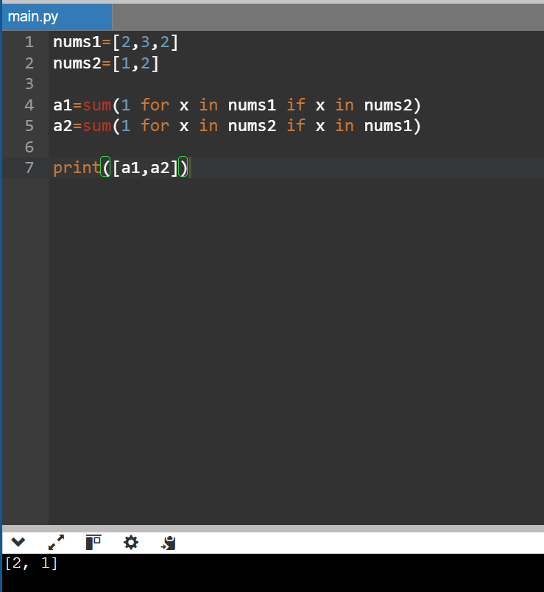

Result
Thus this program is executed successfully

Experiment 3: Sum of Squares of Distinct Counts
Aim
To find the sum of squares of distinct counts of all subarrays.
Algorithm
- Generate all subarrays.
- Count distinct elements in each subarray.
- Square the count.
- Add all squared values.
Code
nums=[1,2,1]
s=0

for i in range(len(nums)):
st=set()
for j in range(i,len(nums)):
st.add(nums[j])
s+=len(st)**2

print(s)
Output
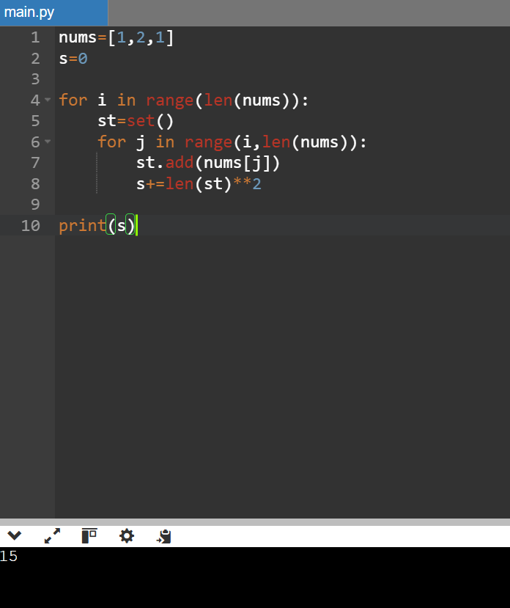
Result
Thus this program is executed successfully

Experiment 4: Count Valid Pairs
Aim
To count pairs whose values are equal and whose index product is divisible by k.
Algorithm
- Traverse all pairs.
- Check equal values.
- Check divisibility condition.
- Count valid pairs.
Code
nums=[3,1,2,2,2,1,3]
k=2
count=0

for i in range(len(nums)):
for j in range(i+1,len(nums)):
if nums[i]==nums[j] and (i*j)%k==0:
count+=1

print(count)
Output
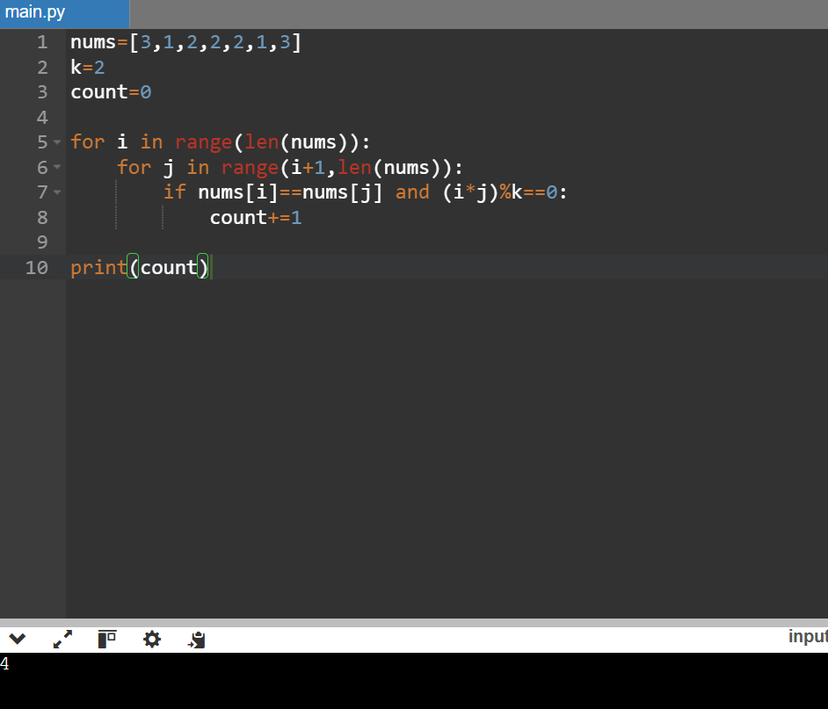

Result
Thus this program has been executed successfully.

Experiment 5: Find Maximum Element
Aim
To find the maximum element in an array.
Algorithm
- Assume first element as maximum.
- Compare with remaining elements.
- Update maximum if larger value found.
- Display maximum element.
Code
arr=[1,2,3,4,5]

m=arr[0]

for x in arr:
if x>m:
m=x

print(m)
Output
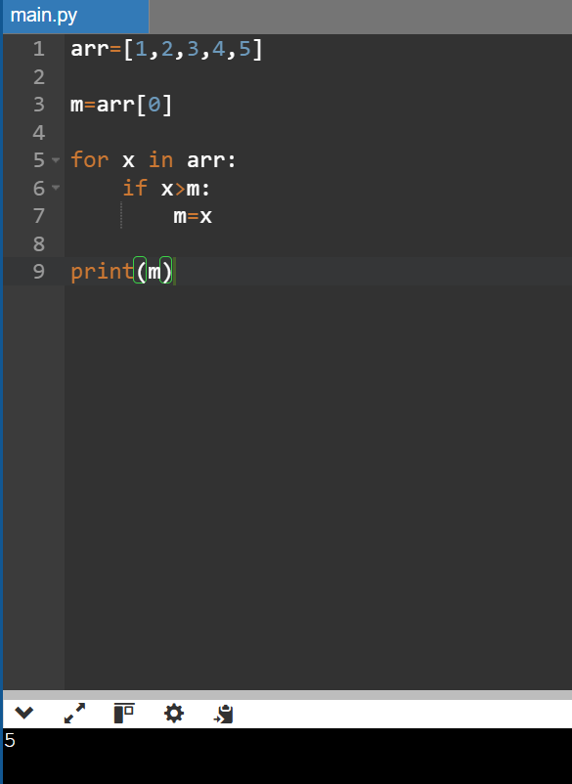
Result
Thus this program has been successfully executed

Experiment 6: Sort and Find Maximum Element
Aim
To sort a list and find the maximum element.
Algorithm
- Sort the list.
- If the list is empty, display a message.
- Otherwise, print the last element.
Code
arr=[5,3,8,4,2]

if len(arr)==0:
print("List is empty")
else:
arr.sort()
print("Maximum Element =",arr[-1])
Output
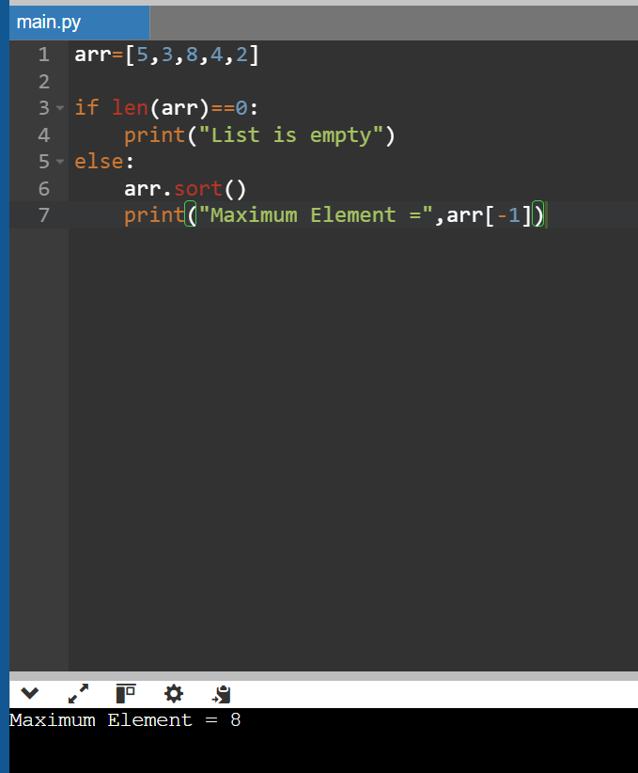
Result
Thus this program has been successfully executed

Experiment 7: Unique Elements in a List
Aim
To create a list containing only unique elements.
Algorithm
- Create an empty list.
- Traverse the original list.
- Add an element only if it is not already present.
- Print the new list.
Code
arr=[3,7,3,5,2,5,9,2]

unique=[]

for x in arr:
if x not in unique:
unique.append(x)

print(unique)
Output
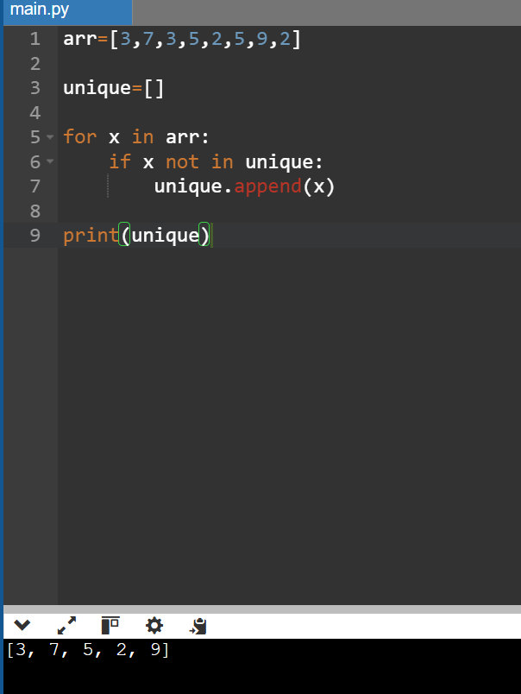
Result
Thus this program has been executed successfully.

Experiment 8: Bubble Sort
Aim
To sort an array using Bubble Sort.
Algorithm
- Compare adjacent elements.
- Swap if they are in the wrong order.
- Repeat until sorted.
Code
arr=[5,3,8,4,2]

for i in range(len(arr)):
for j in range(len(arr)-1-i):
if arr[j]>arr[j+1]:
arr[j],arr[j+1]=arr[j+1],arr[j]

print(arr)
Output
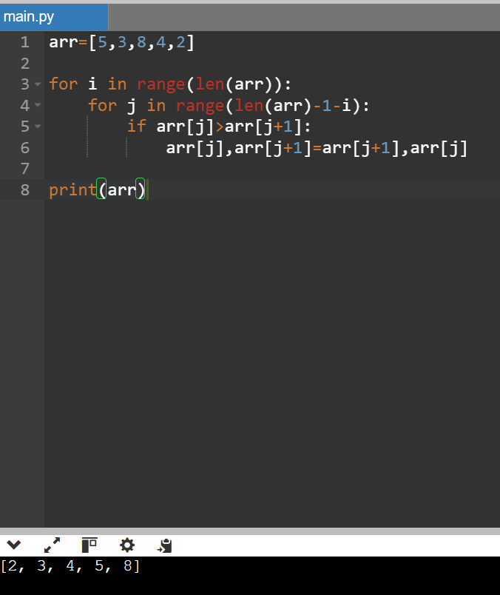

Result
Thus this program has been executed successfully

Experiment 9: Binary Search
Aim
To search an element in a sorted array using Binary Search.
Algorithm
- Find the middle element.
- If key equals middle, return position.
- If key is larger, search right half.
- Otherwise search left half.
- Repeat until found or search space becomes empty.
Code
arr=[-9,3,4,6,8,9,10,30]
key=10

low=0
high=len(arr)-1

while low<=high:
mid=(low+high)//2

if arr[mid]==key:
print("Element found at position",mid+1)
break

elif arr[mid]<key:
low=mid+1

else:
high=mid-1
else:
print("Element not found")

Output
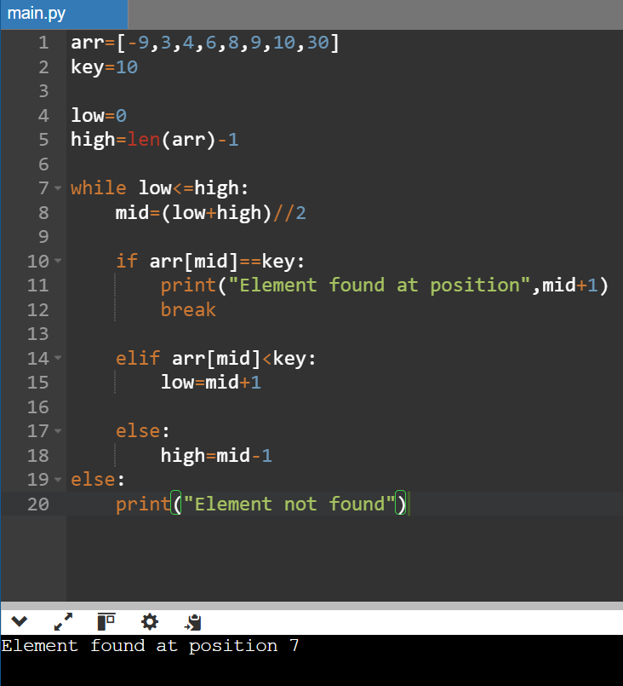

Result
Thus this program has been executed successfully.

Experiment 10: Merge Sort
Aim
To sort an array in ascending order using Merge Sort.
Algorithm
- Divide the array into two halves.
- Recursively sort each half.
- Merge the sorted halves.
Code
def mergesort(arr):
if len(arr)>1:
mid=len(arr)//2

left=arr[:mid]
right=arr[mid:]

mergesort(left)
mergesort(right)

i=j=k=0

while i<len(left) and j<len(right):
if left[i]<right[j]:
arr[k]=left[i]
i+=1
else:
arr[k]=right[j]
j+=1
k+=1

while i<len(left):
arr[k]=left[i]
i+=1
k+=1

while j<len(right):
arr[k]=right[j]
j+=1
k+=1

arr=[5,3,8,4,2]
mergesort(arr)

print(arr)
Output
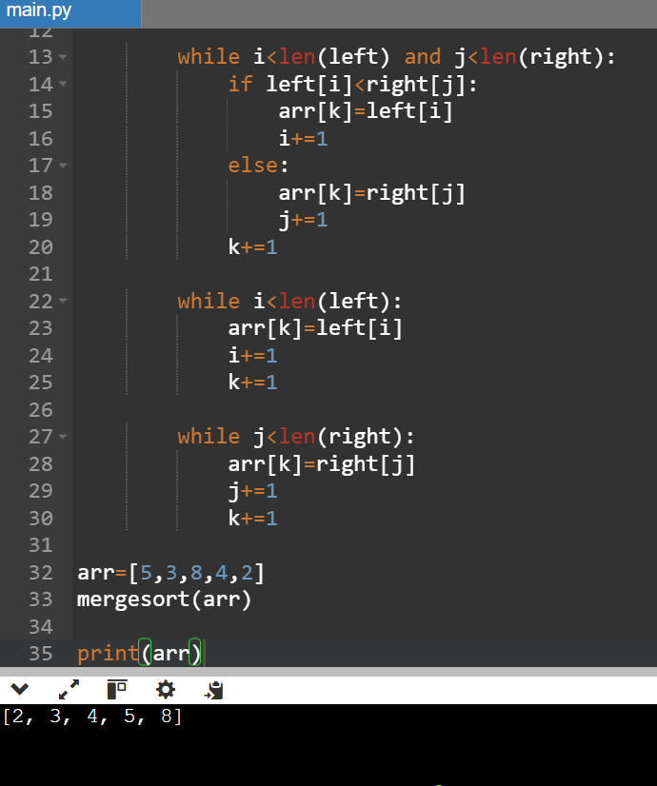

Result
Thus this program has been executed successfully

Experiment 11: Number of Ways to Move Ball Out of Grid
Aim
To find the number of ways to move a ball out of the grid boundary in exactly N steps.
Algorithm
- If the ball moves outside the grid, return 1.
- If no steps remain, return 0.
- Recursively move in four directions.
- Sum all possible ways.
Code
def paths(m,n,i,j,N):
if i<0 or i>=m or j<0 or j>=n:
return 1

if N==0:
return 0

return (paths(m,n,i+1,j,N-1)+
paths(m,n,i-1,j,N-1)+
paths(m,n,i,j+1,N-1)+
paths(m,n,i,j-1,N-1))

print(paths(2,2,0,0,2))
Output
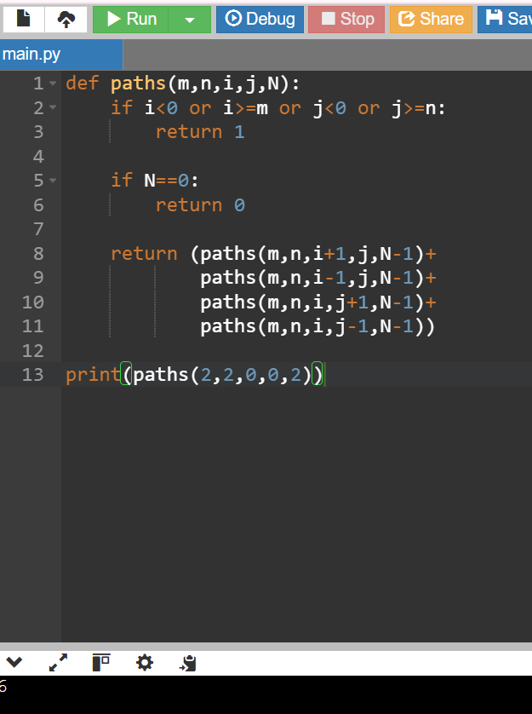
Result
Thus this program has been executed successfully.

Experiment 12: House Robber II
Aim
To find the maximum money that can be robbed from houses arranged in a circle.
Algorithm
- Since first and last houses are adjacent, consider:
  - Houses 0 to n-2
  - Houses 1 to n-1
- Apply House Robber logic on both.
- Return the maximum value.
Code
def rob(nums):
def helper(arr):
a=b=0
for x in arr:
a,b=b,max(b,a+x)
return b

if len(nums)==1:
return nums[0]
return max(helper(nums[:-1]),helper(nums[1:]))
nums=[1,2,3,1]
print(rob(nums))
Output
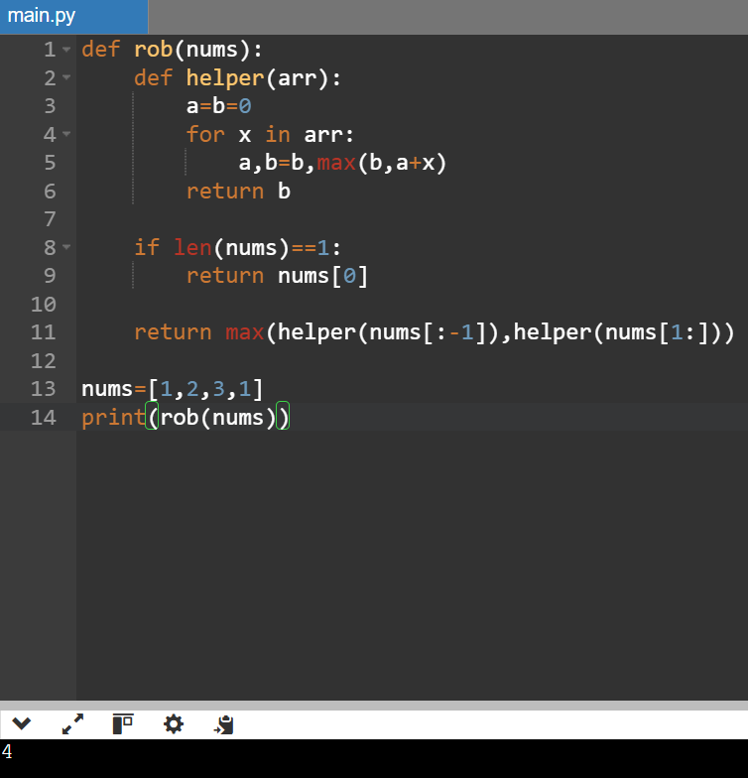
Result:
Thus this program has been executed successfully
Experiment 13: Climbing Stairs
Aim
To find the number of distinct ways to climb a staircase.
Algorithm
- If n ≤ 2, return n.
- Otherwise return ways(n−1)+ways(n−2).
Code
def climb(n):
if n<=2:
return n
return climb(n-1)+climb(n-2)

print(climb(4))
Output
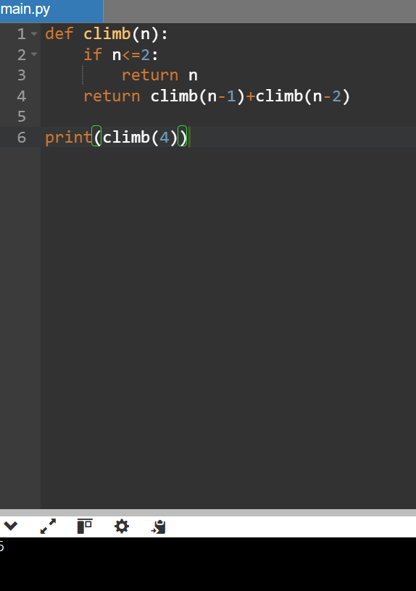

Result
Thus this program has been successfully executed.

Experiment 14: Unique Paths
Aim
To find the number of unique paths from top-left to bottom-right.
Algorithm
- If m=1 or n=1, return 1.
- Otherwise paths = paths(m−1,n)+paths(m,n−1).
Code
def paths(m,n):
if m==1 or n==1:
return 1
return paths(m-1,n)+paths(m,n-1)

print(paths(3,2))
Output
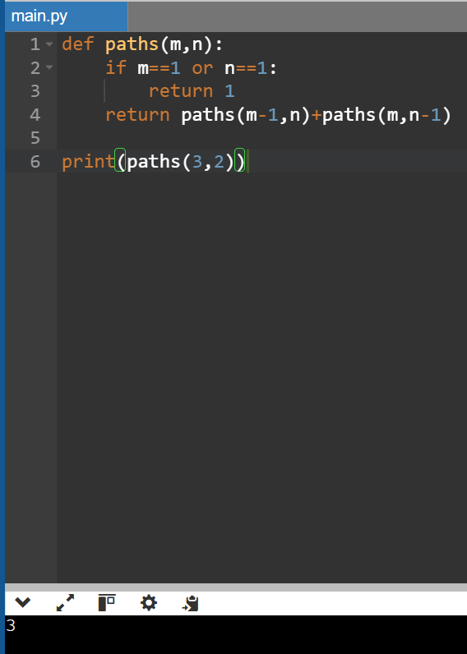

Result
Thus this program has been executed successfully.

Experiment 15: Large Group Positions
Aim
To find intervals of large groups (length ≥ 3) in a string.
Algorithm
- Traverse the string.
- Count consecutive identical characters.
- If count ≥ 3, store start and end indices.
- Print all intervals.
Code
s="abbxxxxzzy"
res=[]
i=0
while i<len(s):
j=i
while j<len(s) and s[j]==s[i]:
j+=1
if j-i>=3:
res.append([i,j-1])
i=j
print(res)
Output
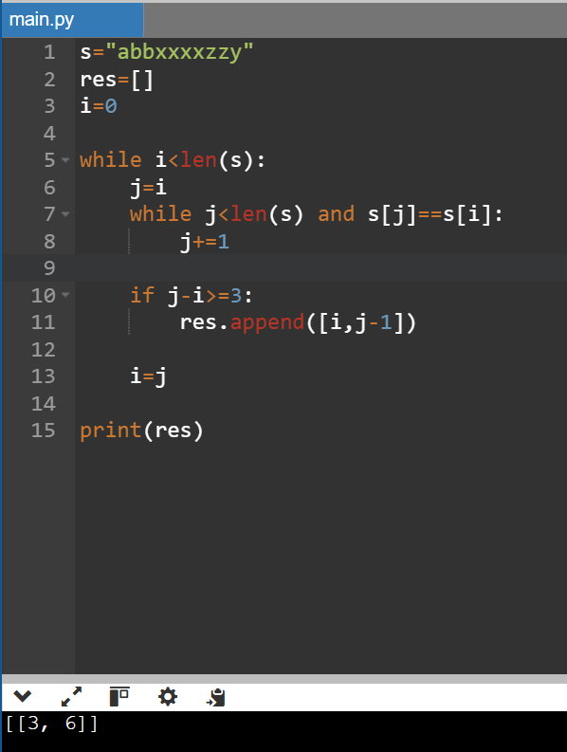
Result
Thuss this program has been executed successfully

Experiment 16: Champagne Tower
Aim
To find the amount of champagne in a given glass.
Algorithm
- Pour champagne into the top glass.
- Overflow is divided equally between two glasses below.
- Continue row by row.
- Return the quantity in the required glass.
Code
tower=[[0]*101 for _ in range(101)]
poured=2
row=1
glass=1
tower[0][0]=poured
for i in range(100):
for j in range(i+1):
extra=max(0,(tower[i][j]-1)/2)
tower[i+1][j]+=extra
tower[i+1][j+1]+=extra
print(min(1,tower[row][glass]))
Output
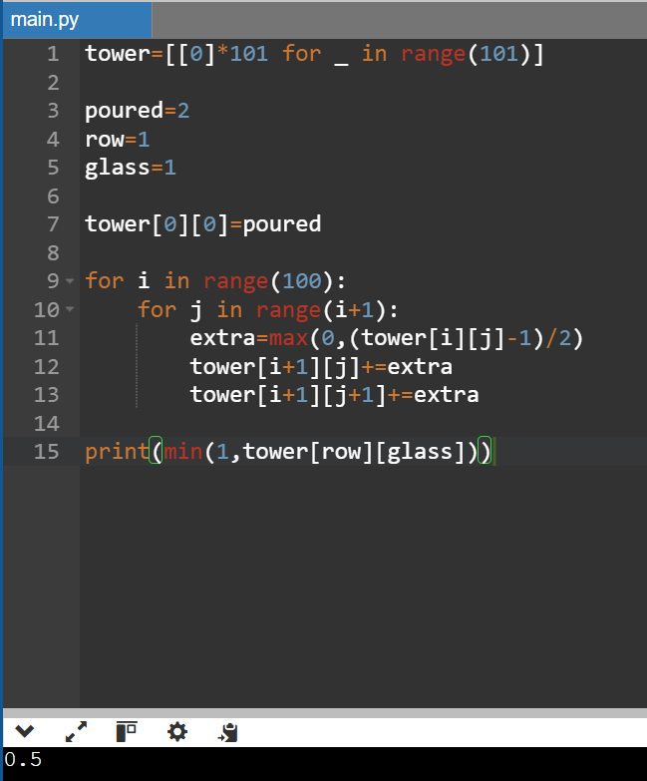

Result
Thus this program has been executed successfully.

